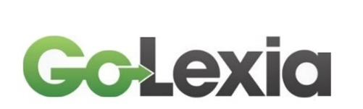
Privacy Notice

Who we are

GoLexia assesses and supports people with specific learning difficulties. We take your privacy seriously. In our Privacy Policy we’ve provided information on when and why we collect your personal information, how we use it, the limited conditions under which we may disclose it to others.
We keep this information secure by means of computer systems that are password-protected, firewall protected and have up to date malware and spyware protection and SSL encryption.

Types of data we collect

Client/learner information

When a client/learner contacts GoLexia to provide specialist support or an assessment, we collect a range of information to enable us to fulfil that service provision.

This might include:
- Personal identifiers and biographical information, for example date of birth
- Contact details – for example home address, email address and telephone number
- Sensitive personal data - for example, details of why an individual seeks an assessment, details of a disability or specific learning difficulty, details of support a client/learner may have had in the past, assessment data, and notes written during and after support or assessment sessions or after other contact with client/learner
- Dates of meetings held with a client/learner
- Family Details – for example details of other family members with whom a client/learner or a client/learner’s school/college/workplace have given us consent to liaise

Why we collect this information

We collect this information to plan and provide the assessment, specialist support or other service the client/learner has requested. If we need to use the information for any other purposes we will state clearly what those are and be sure to obtain consent it if is required to hold and use the information for those additional uses (for example sending a newsletter, which would be completely unrelated to providing support or an assessment).

Who might we share this information with?

We might share this information with the school/college/university attended by the client/learner, in order to inform the relevant staff involved in their support. This will only be done with the express permission of the client/learner.
In respect of Non-Medical Helper support, the information will be shared with Disabled Student Allowance-Quality Assurance Group and will also be covered by that organisation’s privacy policy.

Access to your personal information

You are entitled to view, amend, or delete the personal information that we hold. Email your request to eileen@golexia.com Note: Requests from clients/earners to delete data relating to an individual will be considered on a case by case basis but we may be unable to remove all assessment records and support notes for legal reasons.

Please note that we are legally required to keep information relating to diagnostic assessment for 6 years following the client’s/learner’s 18th birthday.
If you want to view, amend or delete the personal information we hold about you, please contact Eileen Taylor on (01291) 431322 or email eileen@golexia.com

Changes to this Privacy Notice

This Privacy Notice was reviewed on 18th May 2018 and will be reviewed annually on 31st May.

